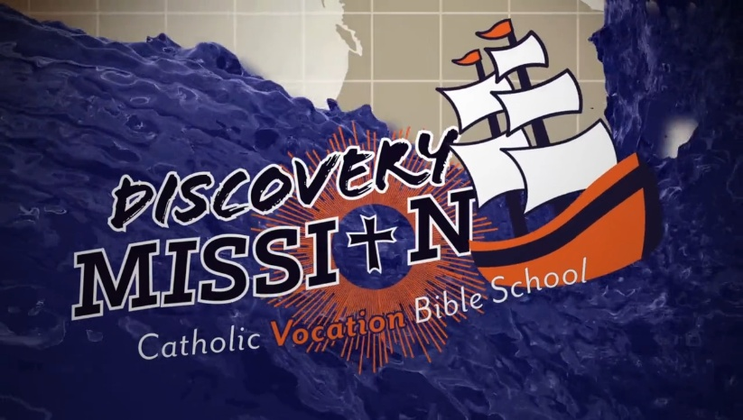
2026 VBS
Sacred Heart & Holy Rosary Parishes
Registration Form
Ages 5-10 yrs.
P.O. Box 6217, Reading, PA 19610
Phone: 610-374-5430
Email: sacredheartreled17@gmail.com

Dear Parents:
Welcome to TOTALLY CATHOLIC, DISCOVERY MISSION VBS – this is the annual event for summer of 2026 at Sacred Heart Church, West Reading. Discovery Mission is a VBS program that teaches children about God’s plan for their life, and discovering their vocation through prayer service and being open to God’s will.

Parent Name:____________________________ Email: ____________________________________________

Home address:______________________________________________________________________________
Cell #:___________________Home Parish:_______________________________________________________

Child’s Name:_________________________Boy/Girl_________ Gr. Completed __________Age (5-10)______
Child’s Name:_________________________Boy/Girl_________ Gr. Completed __________Age (5-10)______

Child’s Name:_________________________Boy/Girl_________ Gr. Completed __________Age (5-10)______
For emergencies we ask for the best way to contact you Cell or E-mail Please provide below:
E-Mail Address (Please Print) _______________________________

Person to contact in case of emergency__________________________________ Phone #_________________

Please complete all information for each child registering:
First Name  (No Nicknames) | Last Name | Boy/  Girl | Grade | Rel. Ed.  Level | Date of Birth | Health/Behavioral/Learning  Issues. Please list all that apply.
** Registration period April 19 to June 30th Fee: $95.00 per child.
**After July 1st $120.00 per child.
**Sacrament Fees for First Holy Communion and Confirmation are due with registration.

►All 2nd Level - Holy Communion Sacramental Fee: $30.00 per child.
►All 7th Level - Confirmation Sacramental Fee: $30.00 per child.

If there is serious financial difficulty, please contact the Religious Education Office or Monsignor DeSantis.
Office Use Only: Date Received: _____________ # of Students ______

Check # ________ Total Amount Received: ______________ Sacrament Fees: HC Confirmation

*** Permission to use photographs on Social Media & Website: Yes / No

